**Bojana’s Documentation**

Hello fellow documentation readers, my name is Bojana Markovska, and I was a participant in this project about an application called “Sweat & Forget”. The whole aesthetic on this app was created by yours truly, meaning, I was responsible about the entire front-end part where I made it look decent in my opinion. It is also responsive so there goes all my blood, sweat and tears throughout this entire app creating journey. Enjoy.

**1. Introduction**

Sweat&Forget is a modern fitness app designed to provide users with a highly personalized workout experience. By leveraging the power of personal data such as activity levels, emotions, and preferences, the app generates unique workout plans tailored specifically to each individual. In addition to these personalized workout routines, Sweat&Forget also offers an integrated music experience, where users can generate a mood-based Spotify playlist to accompany their workouts, making the entire experience both physical and emotional.

The motivation behind Sweat&Forget stems from the growing demand for customization in the health and fitness industry. While generic workout plans exist in abundance, they often fail to meet the nuanced needs of individuals. People’s energy levels, emotions, and fitness goals vary greatly, and Sweat&Forget aims to address these differences by offering a personalized solution. This app is also built on the understanding that music plays a crucial role in enhancing workout motivation and improving performance, so combining both features ensures users stay engaged throughout their fitness journey.

The app is aimed at individuals seeking customized workout routines that align with their current emotional and physical state. Whether they are beginners or seasoned athletes, users can benefit from a unique fitness and music experience that adapts to their needs. By using data-driven insights, the app ensures that each user feels supported in their fitness goals, while also maintaining a sense of fun and enjoyment through music.

The goal of this project is to deliver an engaging, responsive front-end user interface, built in React, that seamlessly connects the survey, workout generation, and playlist creation features. My role in this project focuses on developing the entire front-end experience, ensuring users have an intuitive and enjoyable journey, from taking the survey to discovering their workout plan and personalized playlist.

**2. App Architecture & Technologies Used**

The Sweat&Forget app is developed using **React**, a popular JavaScript library for building user interfaces. React was chosen for its component-based architecture, allowing for the efficient reuse of code, which is crucial when creating complex UIs such as the survey form, workout plan, and playlist generator. The modularity of React components also makes the app easy to scale and maintain.

**HTML** and **CSS** are used to structure and style the app. A mobile-first approach was followed to ensure the app is fully responsive across different screen sizes. Special attention was paid to ensure that the UI adapts smoothly, particularly for key components like the survey form and workout results. CSS flexbox and grid layouts were used extensively for responsive design, along with media queries to adjust font sizes, layout spacing, and visibility of elements on smaller devices.

**JavaScript** powers the logic behind user interactions. For instance, user input is collected from the survey questions, and state management is handled using React’s useState and useEffect hooks. The communication between the front end and backend APIs for fetching the workout plan and generating Spotify playlists is also managed using asynchronous JavaScript functions.

**Components:**

The app is divided into key React components:

* **Survey Component**: Renders the 10 survey questions and tracks user responses. Each answer contains keywords tied to specific workout plans.
* **Workout Plan Generator**: Displays a personalized workout after the survey is completed. This component fetches the workout plan from the backend and displays it on the front end.
* **Playlist Generator**: Allows the user to select their current emotion and fetches a playlist from the Spotify API based on their mood.

**State Management**

State management in the app is achieved through React’s useState hook to manage local component states and useContext to handle global states across components. For example, the survey answers are stored in the app’s state and passed down to the workout generator to produce the final workout plan. This ensures that data flows smoothly between components without unnecessary re-renders.

**3. Responsive Design & User Experience**

One of the main goals of the Sweat&Forget app is to offer a smooth and intuitive user experience across all devices. The design follows a **mobile-first approach**, ensuring that mobile users can navigate and interact with the app without any difficulty. CSS media queries were used extensively to create breakpoints for different screen sizes, adjusting layouts, font sizes, and paddings as necessary.

For example, on mobile devices, the survey form is presented in a vertical scrollable layout, ensuring each question is easy to read and select. On larger screens, the form is displayed in a grid format, making use of the additional space available. The workout plan and playlist generator pages are also optimized for responsiveness, with images, buttons, and text elements scaling dynamically.

The UI/UX design focuses on simplicity and clarity. All buttons are large and easily clickable, and user feedback is provided throughout the app. For instance, loading indicators are shown when workout plans or playlists are being generated, ensuring users are aware of the app’s progress. Consistent color schemes and typography create a cohesive look, enhancing the overall user experience.

**4. Challenges & Solutions**

**Handling Asynchronous Data**

One of the primary challenges in developing the front end was handling asynchronous API calls. Both the workout plan and playlist features required fetching data from the backend and Spotify’s API. To ensure smooth data retrieval, I implemented React’s useEffect hook to manage these API calls effectively, coupled with loading states to enhance the user experience during data processing.

**API Integration**

Integrating with the Spotify API posed its own set of challenges, particularly with OAuth authentication and ensuring the playlist generation matched the user’s selected emotions. I used the official Spotify Web API and handled token management within the app to ensure a secure and reliable connection.

**State Management**

Managing state across different components, especially when passing survey responses and workout plans, was crucial. By utilizing React’s useContext in conjunction with useState, I was able to maintain a clean state across the app, minimizing unnecessary re-renders and ensuring the data flowed seamlessly between the survey, workout generation, and playlist features.

*P1. Home Page*

The home page has a clean and simple design making it more pleasing for the user’s visual experience. The background is a looping video that corresponds to the entire layout of the app, meaning, it enhances the whole structure of the app the entire purpose behind it. The responsiveness is also noticeable when screen size is decreased by font reduction and regular menu collapse into a hamburger menu thus keeping the original simplistic viewpoint.

*P2. Home Page on smaller screens*

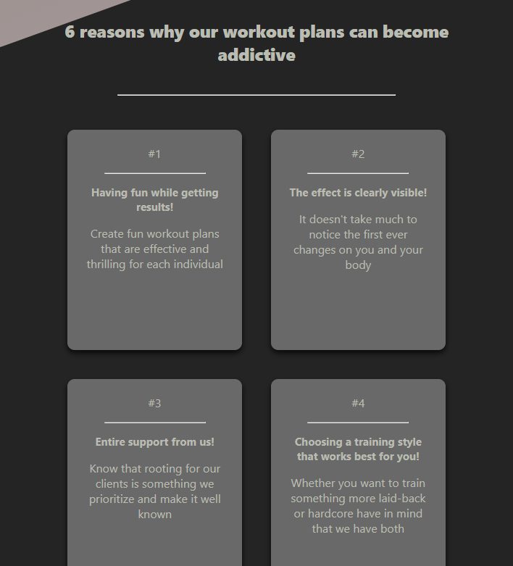

*P3., P4., P5., P6. About Page*

The About page summarizes the meaning of the app and all it has to offer while motivating the users through motivational cards by giving them numerous reasons as to why it is such an inspiring idea to take a different approach in life and start fueling the body by regular exercising by maintaining staying fit, healthy and the state of always being energized.

*P7., P8. Contact Page*

The Contact Page offers users a variety of convenient ways to get in touch with the app's creators, tailored to accommodate individual preferences. Whether through direct messaging, email, or social media platforms, the page is designed to provide users with flexible communication options. Each method is easily accessible, ensuring that users can choose the approach that best suits their needs, whether they prefer a more formal route like email or a quicker option like social media engagement. The goal of this page is to create an open and user-friendly channel for interaction, fostering a seamless connection between the users and the app’s creators.

*P9., P10. Login Page and Register Page*

The login and registration forms within the Sweat&Forget app embody a design philosophy centered on simplicity and elegance. Both forms are crafted with a minimalist approach that emphasizes ease of use without sacrificing aesthetic refinement. The clean, uncluttered layout directs the user’s attention to the essential elements, ensuring a seamless user experience from the moment they interact with the interface.

Each form is thoughtfully arranged, with generous whitespace that contributes to an airy, sophisticated feel, enhancing readability and guiding the user's focus to key actions. The typography is modern yet understated, with clean lines and a harmonious balance between font size and spacing. The color palette is intentionally subtle, using soft tones that evoke calmness and professionalism while maintaining enough contrast to ensure that the form fields and call-to-action buttons stand out clearly.

The design pays special attention to accessibility and responsiveness. The forms are optimized for various devices, from desktop to mobile, ensuring that users enjoy a consistent and intuitive experience regardless of screen size. Button sizes and form fields are ergonomically designed, making interactions effortless, particularly on mobile devices. Additionally, the forms include smooth transitions and animations, offering a refined user experience that feels both responsive and polished.

*P9. Survey Page*

**5. Key Features & Functionality**

**Survey Page**

The survey page is the first interactive element users encounter. It consists of 10 questions, each with 4 answer options that capture essential data, such as the user's activity level and emotional state. The UI was designed to make this process seamless, with each question presented in a card-like structure. Once users complete the survey, the answers are submitted to the backend, where a personalized workout plan is generated based on their responses.

The survey logic was carefully crafted to ensure that user input was captured and stored efficiently. A combination of controlled components in React was used to maintain real-time updates to user answers. The form submission triggers an asynchronous call to the backend API, with a loading buffer displayed to improve user experience during data processing.

**Workout Plan Generation**

After completing the survey, users are presented with a workout plan that’s tailored to their activity level and emotional input. The front-end implementation involved fetching the generated plan from the backend and displaying it in a structured format, including warm-up exercises, main workout sets, and cool-down routines. React's useEffect hook is used here to make API calls once the survey is completed, and the response is rendered dynamically on the workout plan page.

To enhance user experience, a loading spinner is displayed while the workout is being generated. Once loaded, the workout plan appears, formatted using responsive CSS, ensuring it adapts to various screen sizes.

**Playlist Generator**

One of the unique features of Sweat&Forget is its ability to provide a personalized Spotify playlist based on the user's emotions. After users receive their workout plan, they are offered the option to generate a playlist that matches their current mood. This feature leverages Spotify’s API to fetch playlists based on specific emotional keywords such as “happy,” “calm,” “energized,” or “focused.”

The playlist is displayed on a new page, and users can interact with it directly by playing songs within the embedded Spotify player. Handling the playlist API required integrating OAuth for authentication and ensuring smooth communication between the front-end components and Spotify’s services.

**6. Conclusion & Future Improvements**

Overall, Sweat&Forget successfully achieves its goal of providing a personalized workout and music experience for users. The front-end design is responsive, user-friendly, and integrates smoothly with backend services to create tailored workout plans and playlists based on the user’s input.

In the future, additional features could be added to further enhance the app’s functionality. For instance, incorporating more granular workout options (such as body part focus or workout intensity) could offer users even more personalized workout plans. Additionally, the playlist generator could be expanded to include a wider range of music genres or integrate with other music services beyond Spotify.

This project provided valuable learning experience, particularly in state management, API integration, and responsive design. It allowed me to explore the complexities of front-end development and create a seamless user experience that enhances both fitness and enjoyment.